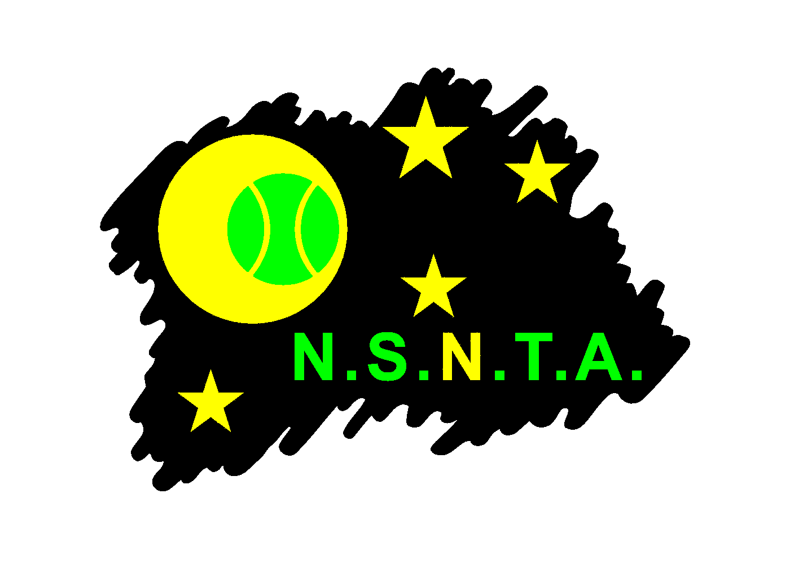
NORTH SUBURBAN NIGHT TENNIS ASSOCIATION INC.
(Reg. No. A15517W)

Email - secretary@nsnta.org / Web - www.nsnta.org

This form must be used to report any alleged breaches of the NSNTA Code of Conduct. Only Club Secretaries or NSNTA Delegates can report alleged breaches. Players and captains should contact their club if they wish to make a report.

Captains should seek to resolve disputes on the night in accordance with the Dispute Resolution Procedures. Minor Code of Conduct violations should be resolved between representatives of the two clubs concerned. If the matter cannot be resolved by the two clubs, or if the breach is serious, it must be reported in writing to the Association Secretary using this form.

Completed forms should be emailed to the NSNTA Secretary at secretary@nsnta.org.

Person reporting breach of the Code of Conduct

Name:

Role (Club Secretary/NSNTA Delegate):

Club:

Date:

Contact phone number:

Contact email address:

Have you attempted to resolve this issue directly with the other club? (provide details of who you discussed it with and what actions have been taken so far):

Details of alleged breach/es of the Code of Conduct

Date of alleged breach of Code of Conduct:

Name/s of player/s and/or spectator/s alleged to have breached the Code:

Club:

Number/s of alleged Code of Conduct violation/s:
(refer to violations numbered 1 to 13 in the NSNTA Code of Conduct)

Competition, grade and match details (e.g. B Grade 2 Mixed):

Details of alleged breach:
(Please provide as much detail and evidence as possible about the alleged breach of the Code of Conduct. Further information, such as witness statements, should be attached)

Note: It is the responsibility of the club reporting an alleged breach of the Code of Conduct to provide sufficient information to support their report. This form and any other materials attached will be made available to the club of the person/s alleged to have breached the Code of Conduct to provide them with an opportunity to respond.

